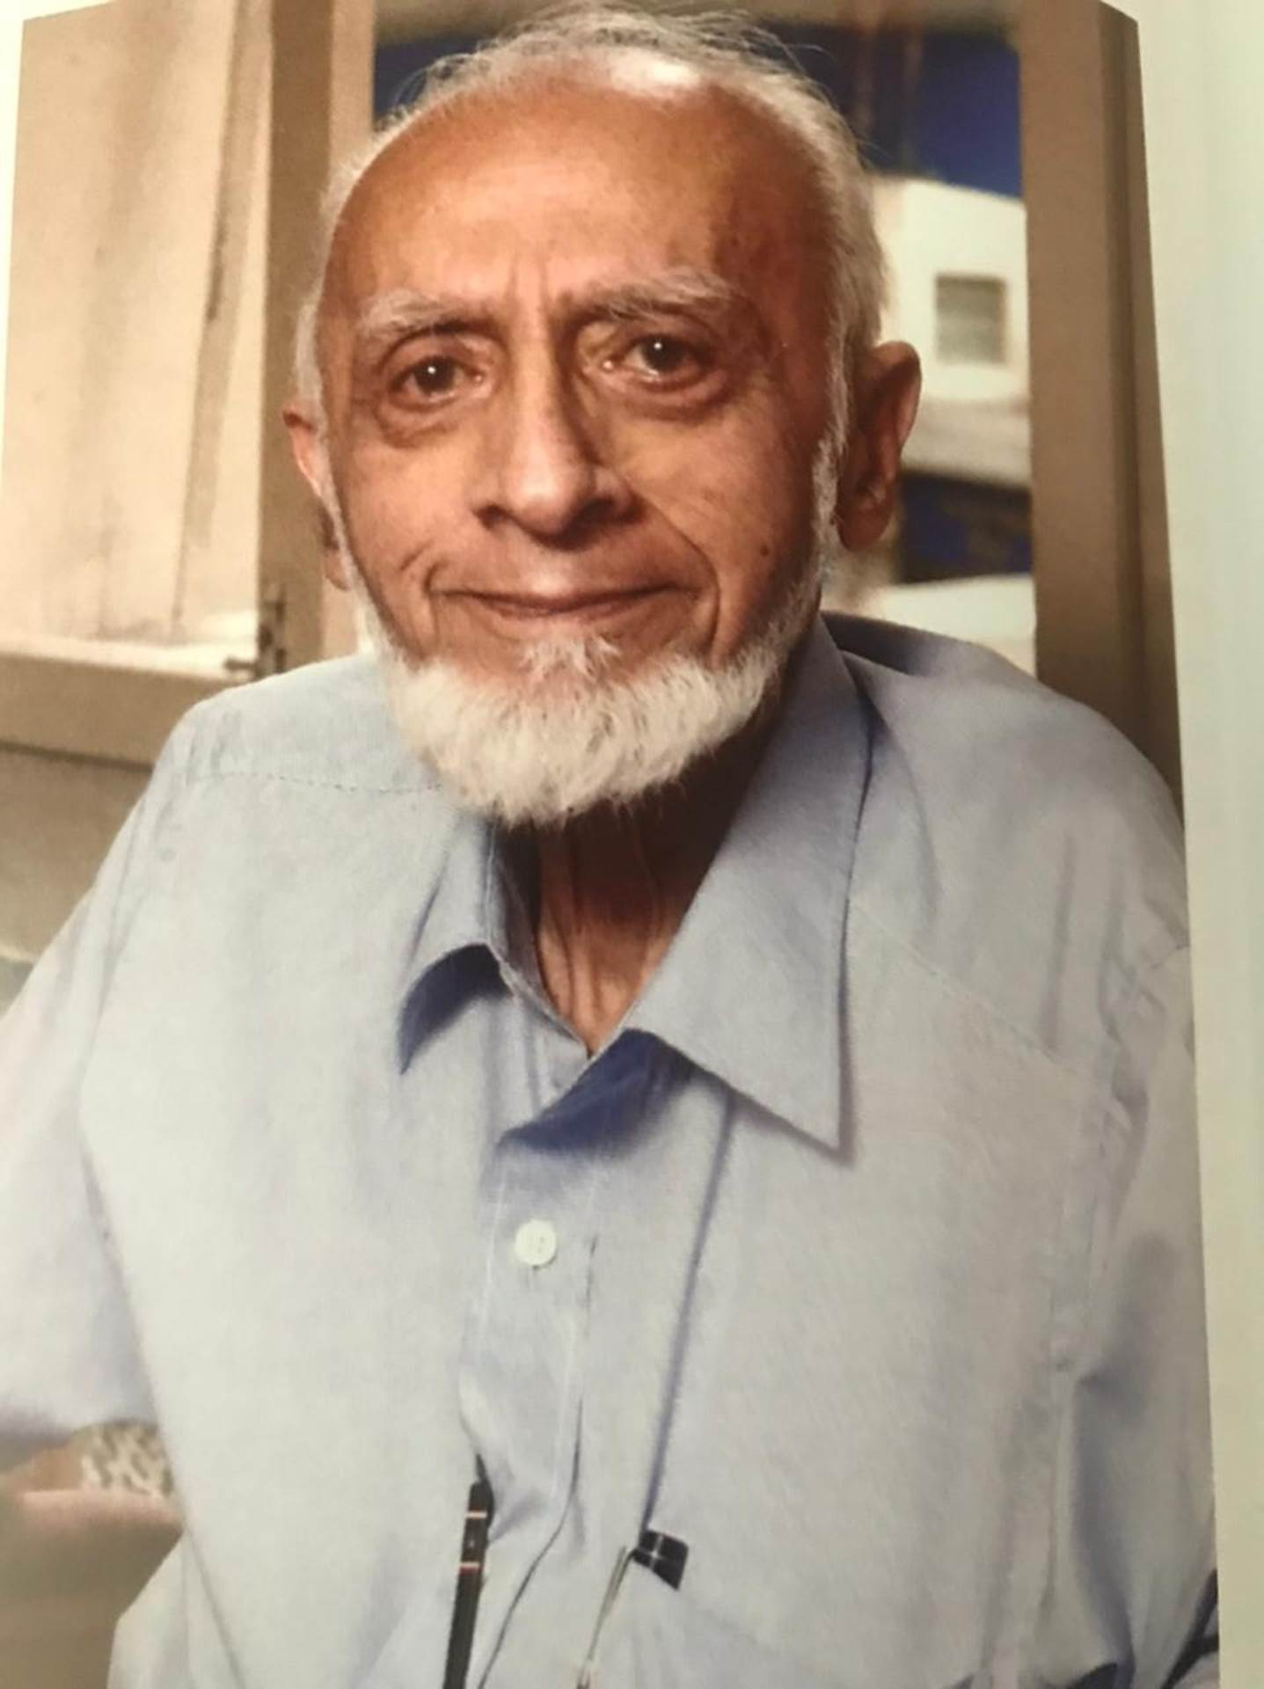

OBITUARY YACOOB EBRAHIM DAWOOD.

I, like many others, was sad to learn today, of the passing away of Yacoob Ebrahim Dawood at the ripe old age of 93. His departure leaves a big void in those who knew this likeable character, soft spoken, with a gentle smile and with humility in spades.

While many people so often get lost in day-to-day superficiality, in all sorts of confusion and strife, Bhai Yacoob was someone who would create a space for stirring emotion; he had the vision and the clarity to make us feel a little wiser and happier. That is why my privileged moment was meeting him every week in his office in Port Louis - apart from reminiscing about the rich history of the Meiman community, we spent a fair amount of time in our attempt to solve the problems of our society, at least, on paper. We would also talk about improving the quality of education at Aleemia College as well as ways of investing the wealth of the Jummah Mosque. He had the experience of age, of his tenureship, [a thankless task], in important institutions like the Jummah Masjid, which is the mouthpiece of the Muslim community on religious affairs, and the Halqa e Qadria Society which runs a Dar ul Ulum and the Aleemia College. On paper at least, we would find solutions to 75 per cent of the problems on the day’s agenda. I always left him enormously enriched by his wisdom and vision.

Bhai Yacoob’s life experience grew through the inheritance and management of the very successful Noor Mohamed Osman business establishment which was involved in importing building materials, foodstuffs and household goods. His ancestors owned a multi-national company with offices in Rangoon, Bombay, Calcutta, Karachi and Ceylon that would buy rice in Burma for worldwide distribution, including Mauritius; on the way back, the ships would transport Mauritian sugar to India.

Apart from the wholesale rice business which provided staple food to the indentured labourers on long-term credit thereby helping towards the viability of the sugar industry, the family also ran a match factory, which was located on the ground of the present day UBS HQ, and that proved useful as during the Second World War matches were scarce. Today, Bhai Yacoob is leaving behind, among his legacies, significant contribution in the creation of MOROIL company and his agency of Pioneer products.

I would like to express my heartfelt condolences to his family among whom he insisted to spend his Eid, his wife Sitara whom he married in Bangalore, his four children Noorjahan, Farhat, Akhtar, Firdaus and their spouses and his 12 grandchildren at the loss of this representative of a rare and dwindling species of visionaries. May Allah SWT grant him Jannat ul Firdaus.

Dawood Auleear

10 June 2021

**From:** Dawood Auleear [<mailto:capnord@intnet.mu>]   
**Sent:** Thursday, June 10, 2021 3:42 PM  
**To:** [star_press@live.com](mailto:star_press@live.com)  
**Subject:** OBITUARY YACOOB EBRAHIM DAWOOD.

The Editor in Chief,

Star Newspaper,

Port louis.

Dear Sir,

I would really appreciate if you could kindly publish this obituary on this important Muslim figure.

Sincerely,

Dawood Auleear,

10 June 2021

OBITUARY YACOOB EBRAHIM DAWOOD.

I, like many others, was sad to learn today, of the passing away of Yacoob Ebrahim Dawood at the ripe old age of 93. His departure leaves a big void in those who knew this likeable character, soft spoken, with a gentle smile and with humility in spades.

While many people so often get lost in day-to-day superficiality, in all sorts of confusion and strife, Bhai Yacoob was someone who would create a space for stirring emotion; he had the vision and the clarity to make us feel a little wiser and happier. That is why my privileged moment was meeting him every week in his office in Port Louis - apart from reminiscing about the rich history of the Meiman community, we spent a fair amount of time in our attempt to solve the problems of our society, at least, on paper. We would also talk about improving the quality of education at Aleemia College as well as ways of investing the wealth of the Jummah Mosque. He had the experience of age, of his tenureship, [a thankless task], in important institutions like the Jummah Masjid, which is the mouthpiece of the Muslim community on religious affairs, and the Halqa e Qadria Society which runs a Dar ul Ulum and the Aleemia College. On paper at least, we would find solutions to 75 per cent of the problems on the day’s agenda. I always left him enormously enriched by his wisdom and vision.

Bhai Yacoob’s life experience grew through the inheritance and management of the very successful Noor Mohamed Osman business establishment which was involved in importing building materials, foodstuffs and household goods. His ancestors owned a multi-national company with offices in Rangoon, Bombay, Calcutta, Karachi and Ceylon that would buy rice in Burma for worldwide distribution, including Mauritius; on the way back, the ships would transport Mauritian sugar to India.

Apart from the wholesale rice business which provided staple food to the indentured labourers on long-term credit thereby helping towards the viability of the sugar industry, the family also ran a match factory, which was located on the ground of the present day UBS HQ, and that proved useful as during the Second World War matches were scarce. Today, Bhai Yacoob is leaving behind, among his legacies, significant share in the MOROIL company and his agency of Pioneer products.

I would like to express my heartfelt condolences to his family among whom he insisted to spend his Eid, his wife Sitara whom he married in Bangalore, his four children Noorjahan, Farhat, Akhtar, Firdaus and their spouses and his 12 grandchildren at the loss of this representative of a rare and dwindling species of visionaries. May Allah SWT grant him Jannat ul Firdaus.

Dawood Auleear

10 June 2021